13 Years of TSA Claims Data

Mark Raney - April 9, 2020

## Introduction

Whether it’s on the tail end of an exhausting trip or during the beginning of an exciting prospective vacation, few worse things can happen during air travel than finding out your luggage never quite made it to baggage claim, or worse, made it in pieces. The question arises; what exactly is one to do in this situation? In most cases, the best course of action would be to file a claim to the TSA stating the reason for the claim, the items which were damaged/lost, and how much you feel you deserve in financial compensation. This unfortunately, as picked up [by](https://www.usatoday.com/story/news/2015/07/02/tsa-damage-tops-3m/29353815/) [numerous](https://www.latimes.com/business/la-fi-travel-briefcase-tsa-claims-20170825-story.html) [researchers](https://thehill.com/policy/transportation/347623-study-passengers-struggle-to-get-reimbursement-from-tsa-for-lost), is rarely a painless process. The general consensus surrounding the topic is that there’s a very good chance you will not receive any compensation for the damages, and even in the event that you do, it will rarely be wholly matched, leaving you with a fraction of what you asked for.

The TSA, as expected, keeps a log of all claims made since 2002, free for public use, which enables us to examine the accuracy of this sentiment as well as looking for differences in how separate airports across America tend to deal with claims against them.

## Ethical Consideration

With regards to the topics this analysis extends to, there are a few notable ethical considerations to acknowledge. Firstly, it is important to note who could potentially be negatively impacted. For the reason that part of this project includes generating a ranking of American airports with regards to how they respond to claims filed against them, they would appear to potentially suffer the most damage resulting from poor practices yielding incorrect findings as it could persuade passengers to fly out of another neighboring airport if possible. In addition to that, the TSA as an organization may be susceptible to negative feedback resulting from improper findings as it may paint them in a worse light as being less consistent/trustworthy than in deserving.

The other side of the necessary ethical considerations revolves around the fact that all conclusions made through data analysis are being derived from a fairly limited scope of information relative to all that is considered by the TSA in making their decisions. Specifically, what is perhaps the most important missing information is the context behind the subject item of the claim, such as sentimental value which is completely lost in the transcription of the claims to the dataset. The hope relating to this matter is that because the dataset contains multiple tens of thousands of claims from many different airports the impacts this missing information has is lessened, though there’s ultimately no way to be certain that is the case.

## Data Explanation and Exploration

Going into the project, the belief I had was that the TSA, in responding to claims, was largely inconsistent across different American airports. In addition to that, I followed the belief of the aforementioned research articles that there would be a high probability of not receiving any reimbursement for lost/damaged luggage.

Three datasets were used for this project. The primary dataset used that, in reality, was five separate sets containing the same data for different years which were bound together stored all the variables relating to individual claims, from which the most used variables are as follows:

* Airport Code/IATA code (Used to identify at which airport the incident occurred)
* Claim Type (Reason for claim – lost luggage, broken belongings, etc.)
* Claim Amount (Reimbursement requested from claim filer – only included up to 2009)
* Item (Subject of claim)
* Disposition (Decision made by TSA – approve in full, settled, or denied)
* Close Amount (Amount of money given as reimbursement)

As for the other two datasets, one contained information on what state airports were in as well as the coordinates of said airports. The other contained a record of all US domestic flights from 1990 to 2009 which included the origin airport as well as the number of passengers on the flight. These values were used to measure the level of traffic each major airport saw.

As was previously mentioned, the provided information is somewhat limited which places restraints on the possible relations we can measure. In addition to that, with such a limited scope, certain assumptions are made, such that the majority of claim amounts are reasonable and claims of the same type exhibit similar situations. These of course are not always going to be the case, and it is important to recognize that and understand that conclusions drawn that were derived from the data is subject to lose accuracy because of it.

Using the above datapoints, three notable variables which were generated include:

* Chance of Return
  + This is an airport-specific variable in that each unique value applies to a single airport. This variable is measuring the probability that a claim will be accepted at a given airport. The formula for this is the number of claims accepted at a specified airport divided by the total claims made against the same airport.
* Proportion returned
  + This variable is specific to each individual claim. Given that a claim was indeed accepted, this variable measures the proportion of the close amount relative to the claim amount. The formula for this is the claim amount divided by the close amount.
* Average Airport Return
  + Another airport specific variable, this value measures the average proportion returned of all claims made against a specific airport. This value is achieved through taking the mean of all proportion returned variables of the same airport code.

Of course, several more variables were generated to try and test the hypothesis, though these three serves as the focal point of the project.

For the sake of contextualizing the data, two maps are presented below.

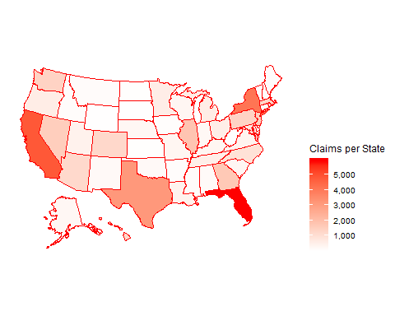

With this map, we can see where the majority of claims are coming from and, as expected, Florida, California and New York are at the top of the list, unsurprising given they are some of the most highly populated regions and also hold multiple of the most active airports in the country.

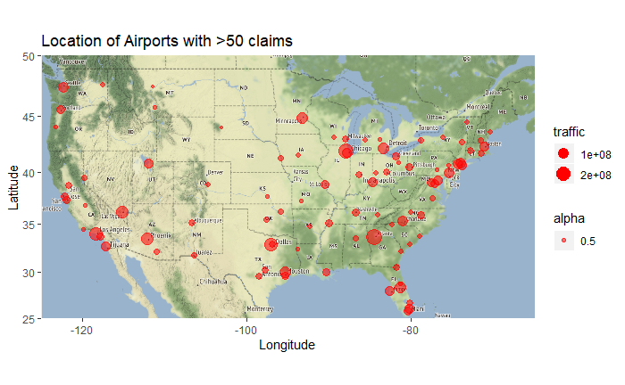

In this map, we can see the airports with the highest traffic and largest number of claims made against them. There are a few important things to take from this visual, one aspect being the level of traffic an airport receives which is a measure of the total number of passengers, denoted by size of the marker, who have flown out of the airport. The reason this is an important piece of information is because as an attempt to rank airports based on how they respond to claims, the probability that an event prompting a claim occurs is taken into account, which is a measure of the number of claims filed to the amount of passengers who have gone through the airport. The next piece of information to take from the map is more general, and simply that these are the airports which are being compared based on their responses to claim requests.

## Statistical Analysis and Interpretation

***Relationships between Chance of Return and Average Proportion Returned***

The first statistical model conducted after successfully wrangling the data to yield the three aforementioned datapoints was that of a single variable t-test measuring the distribution of the average airport return. This was run with a mu = 0.7951, the mean value across all airports. The results are as follows:

t = -0.0017547 df = 115 p-value = 0.9986

95% Confidence interval: 0.7899853 0.8002057

Seeing these results, it’s fair to say that it’s highly suggested by the large p-value that among different airports in the country, the distribution of average return on claim follows a normal distribution, which suggests that the initial hypothesis is incorrect, and there is indeed a degree of consistency across airports regarding that datapoint.

Next, following the same principle as above, we ran another single variable t-test, this time measuring the distribution of the variable “chance of return” across airports. This was run with a mu = 0.47029, the mean value across all airports. The results are as follows:

t = -0.00033669 df = 114 p-value = 0.9997

95% Confidence interval: 0.4574302 0.4831454

Again, the results suggest that the data in all likelihood follows a normal distribution, once again suggesting there is at the very least some consistency across airports in the US with regards to how likely they are to accept a given claim.

Furthermore, if we use the two variables to generate a scatterplot where each point represents a single airport, the results of these two tests certainly pass the eye-test.

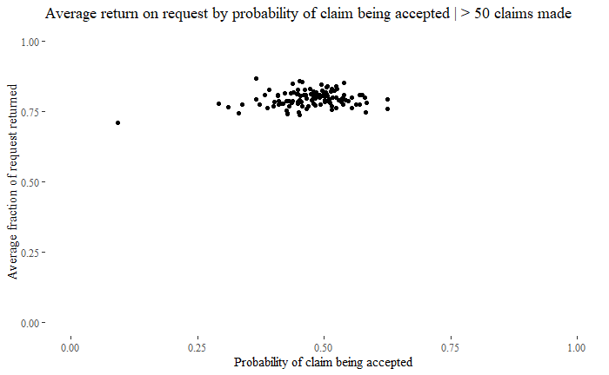

As expected with regards to the results of the statistical models, the collection of the airports is quite compact, save for a single point which was registered as “foreign airport” in the dataset. Of course, it is apparent that the points are far more compact along the y-axis (Average Return) than the x-axis (Chance of Return). With this, we can guess that far more points along the y-axis fit within the 95% confidence interval from the statistical model, suggesting there is a greater level of consistency as it pertains to that variable. These two density plots are a good demonstration of this separation:

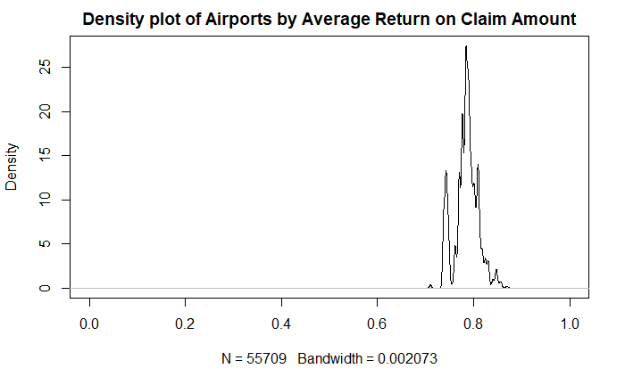

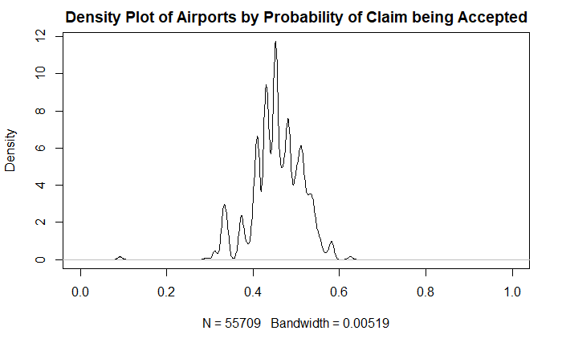

The difference in the width of these two density plots illustrates the difference in how consistent the TSA is across different airports with regards to these two variables. Where one is far narrower, having a range of approximately .15, the other has a range of about .30, to which we can say with near certainty that average return is far more consistent than the claim acceptance rate throughout different airports.

***Relationship between Claim amount and Proportion Returned***

The next statistical model ran, this time a linear model, examines the relationship between claim amount and proportion returned. The results of the model are as follows:

Estimate p-value: < 2.2e-16

(Intercept) 7.910e-01

Claim.Amount -1.672e-05 Adjusted R-squared: 0.01452

Examining the results, it’s reasonable to say that while the model does suggest there is indeed a statistically significant relationship between the two variables, it’s only a very general trend where, as the adjusted r-squares indicates, it would not at all be unexpected to receive a proportion of your initial claim amount that is nowhere close to what the model predicts. This is further demonstrated through the plotting of these points:

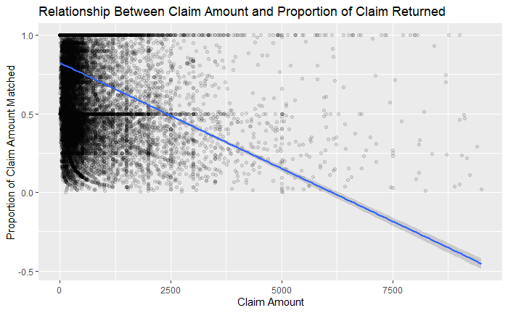

One major piece of information to take from this is that many settled claims fell under either 100% matched (approved in full) or 50% matched (settled). This, realistically, isn’t too much of a revelation considering the amount of claims the TSA receives per day, it’s reasonable to assume they don’t want to expend resources to meet with an arbiter to settle on some specific amount, and would rather take the path of least resistance and simply offer half of what is asked for, even if it means potentially giving away more than is deserved.

***Relationships between Claim Type and Proportion Returned***

The next statistical model used was another linear model, this time examining the relationship between claim type and proportion returned. The results of this model are as follows:

Coefficients:

Estimate

(Intercept) 0.732675

Claim.TypeEmployee Loss (MPCECA) 0.097166

Claim.TypeMotor Vehicle 0.134300

Claim.TypePassenger Property Loss 0.049288

Claim.TypePassenger Theft 0.064598

Claim.TypePersonal Injury -0.255189

Claim.TypeProperty Damage 0.064167

Adjusted R-squared: 0.004567

p-value: < 2.2e-16

Largely similar to the previous model, we can see that while it is suggested that there is a statistically significant relationship between the two variables, ultimately the model represents a small percentage of the relationship, and should again be taken as a very general trend. One interesting point however, is that all claim types increase the proportion returned except for cases of personal injury which has a negative relationship suggesting that the proportion your receive relative to your claim amount decreases relative to the other claim types.

Expanding upon this relationship, we demonstrated the model in the form of a boxplot:

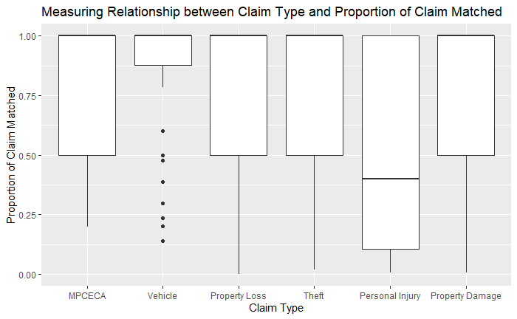

In this model, it is clear how, as mentioned above, many claims when matched will yield either 100% or 50% of the claim amount, demonstrated by many of the upper/lower bounds falling on those values.

***MARK Score***

The MARK score, an abbreviation for “Mark’s airport rating, k?” is a numerical value used to rank airports based on three variables:

* Likelihood of a claim being necessary
* Proportion of claim matched, assuming it was accepted
* Probability of claim being accepted

The latter two are reasonably self-explanatory and have been covered well enough thus far, but the first one is a new value generated solely for calculating the MARK score. This value is calculated by dividing the number of claims made against a given airport divided by the total number of passengers who flew out of the same airport.

The MARK score is calculated as the product of the proportion of claim matched and the probability of claim being matched which then is multiplied by (1 – likelihood of claim being necessary). Alone, the value is rather arbitrary, and for the most part only has use in comparing two or more separate airports.

The dataset containing the MARK score of each airport is included separately.

***Predictor Model***

The last statistical model ran on the data was yet again a linear model, though this time as multivariate regressions constructed with the intention of using it with a predictor model to both guess the probability of reimbursement being provided as well as the most likely proportion of your claim amount received.

The two models both used the same variables of:

* Airport Code/IATA code
* Claim Amount
* Claim Type
* Item

One model, as stated above, measured for proportion returned, and the other measured probability of reimbursement. Given that the models have over a hundred coefficients, largely on account of testing all separate airports, it would be largely unhelpful to include the results of the model, though again it’s worth noting that the results suggest a statistically significant relationship among all variables, though accounting for only a small portion of the data, and the results of the model should again be taken as a very general predictor, where it should be wholly expected that making a claim with the exact same inputs may yield an entirely different answer to what is predicted.

With that said, we chose to run the model on three different airports, LAX, ATL, and ORD all with the same claim type, amount, and item (Property loss, $100, camera). The predicted values are as follows:

* LAX
  + Proportion Returned: 0.6058138
  + Chance of Return: 0.4276423
* ATL
  + Proportion Returned: 0.6315596
  + Chance of Return: 0.4108050
* ORD
  + Proportion Returned: 0.6341700
  + Chance of Return: 0.4503878

It should come as no surprise that all values are nearly identical when considering the statistical models and visuals above suggesting an impressive level of consistency across airports.

## Conclusions

Largely going against the initial hypothesis, the data suggests that the TSA is an organization which exhibits a high level of consistency with regards to how it responds to claims across American airports. This is of course not a statement on the whole of TSA as there are a multitude of valid reasons beyond their reactions to claims which one may choose to agree/disagree with how the organization is conducted.

It should be noted however, that the question of whether the TSA is consistent enough is largely up to opinion. As was seen in the first set of statistical models, there is indeed a demonstrated level of consistency by virtue of both distributions following that of a normal distribution, but whether one believes that a range of 15% or a range of 30% among airports is too wide a gap is entirely subjective.

As for the [articles](https://www.nj.com/data/2018/04/tsa_airport_tsa_lost_baggage_tsa_damaged_baggage_tsa_theft_tsa_claims_tsa_rules_tsa_precheck.html) positing that the TSA is not entirely fair in their decisions, I would certainly say that a mean claim acceptance of 0.47029 is unreasonably low. This again however is something that falls under personal opinion.

Also, while there certainly appears to be a strong level of consistency across airports with regards to proportion of claim amount met and probability of claim being accepted when looking at averages of the data, it’s apparent through the following statistical models that on a “case to case” basis, there certainly does appear to be a large level of randomness attributed to the disposition made by the TSA.

This unfortunately highlights the main issue with the data in that we’re missing the invaluable context of each situation which forces us to assume that every claim is equally reasonable which simply isn’t the case, and is why all results from this analysis should be taken as very general trends.

Using this project as a foundation for exploring further into the topic, something which I would be very interested to see is how factors such as race, gender, socioeconomic status, etc. of the individual who filed the claim affects the disposition. This is something I initially wished to use as a focus in this project but lacked the appropriate data to test a hypothesis.

***Citations:***

***Articles:***

Disha Raychaudhuri | NJ Advance Media for NJ.com. “Good Luck Getting Money from the TSA for Your Lost, Damaged Luggage.” *Nj*, 22 Apr. 2018, [www.nj.com/data/2018/04/tsa_airport_tsa_lost_baggage_tsa_damaged_baggage_tsa_theft_tsa_claims_tsa_rules_tsa_precheck.html](http://www.nj.com/data/2018/04/tsa_airport_tsa_lost_baggage_tsa_damaged_baggage_tsa_theft_tsa_claims_tsa_rules_tsa_precheck.html).

Penzenstadler, Nick, et al. “Lost, Stolen, Broken: TSA Pays Millions for Bag Claims, USA TODAY Investigation Finds.” *USA Today*, Gannett Satellite Information Network, 2 July 2015, [www.usatoday.com/story/news/2015/07/02/tsa-damage-tops-3m/29353815/](http://www.usatoday.com/story/news/2015/07/02/tsa-damage-tops-3m/29353815/).

“That Lost or Damaged Item from Your Last Flight? The TSA Probably Won't Pay What You Ask.” *Los Angeles Times*, Los Angeles Times, 25 Aug. 2017, [www.latimes.com/business/la-fi-travel-briefcase-tsa-claims-20170825-story.html](http://www.latimes.com/business/la-fi-travel-briefcase-tsa-claims-20170825-story.html).

Zanona, Melanie. “Study: Passengers Struggle to Get Reimbursement from TSA for Lost, Damaged Items.” *TheHill*, 23 Aug. 2017, thehill.com/policy/transportation/347623-study-passengers-struggle-to-get-reimbursement-from-tsa-for-lost.

***Datasets:***

“TSA Claims Data.” *Department of Homeland Security*, 5 June 2019, [www.dhs.gov/tsa-claims-data](http://www.dhs.gov/tsa-claims-data).

AshishSharma. “USA Airport Dataset.” *Kaggle*, 27 Feb. 2018, [www.kaggle.com/flashgordon/usa-airport-dataset](http://www.kaggle.com/flashgordon/usa-airport-dataset).

Datopian. “Airport Codes.” *DataHub*, datahub.io/core/airport-codes.